Braden Zufelt – TCBS Member-at-Large (Res)

Members of College,

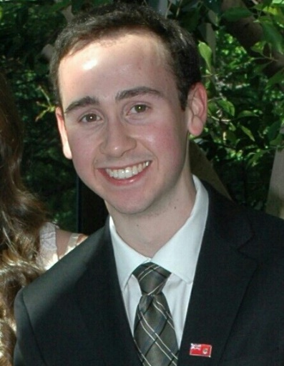As you well know, Trinity College differs from other institutions in that we are a direct democracy. As such, we are well-versed in the democratic process, the great pillar of Western civilisation. It is so prevalent, in fact, that we often unintentionally find ourselves immersed in it, contributing to College life by simply pursuing our personal interests.

I understand that this democratic pillar cannot stand on its own. It requires a foundation, individual pillars which contribute to its strength and stability. These come in the form of the clubs and societies in which we pursue our beliefs and ambitions. They are the means in which we find communities suited to our nature. They allow us an environment where our views can be heard and respected. They allow us a voice. These societies, different though they may be, unify into one institution, they become the democratic pillar which is Trinity College.

I want to ensure that clubs of all purposes have an equal opportunity in creation. I feel it is my duty to do my part in furthering democracy in a world which is increasingly undemocratic, and this can begin here. I am a well-organised, approachable individual with a firm belief in the strength of the democratic process and if you support me in my bid for a seat on the Trinity College Board of Stewards, I will ensure fairness in the establishment of clubs at Trinity College.

Regards,

Braden Zufelt

braden.zufelt@mail.utoronto.ca